
By: Gerritt Hong – CCNP

LOCAL ARTIFICIAL INTELLIGENCE LAB

Purpose
The purpose of this lab was to set up a local artificial intelligence system connected to a web server. The goal was to get a local AI model running on my computer using LM Studio and make it accessible through a simple web interface built with Python and Gradio. This lab was mainly focused on understanding how local servers work, how to check network connections, and how to make the AI respond through the network.
Background
Now that artificial intelligence is a part of everyday life, people use it through chatbots, voice assistants, and recommendation systems. AI is usually run in a cloud server by large companies. For example, this means that when someone asks a command for AI, the data travels through the internet to a data center where the computer understands and sends back an answer. However, in this lab, I learned understood that AI can be run locally on my own computer instead of running through a cloud. This is important because AI is more efficient on a personal device since it is private and people have more control over it.
The main program used in the lab was LM Studio. LM Studio allows people to download and use AI directly on their computers without internet connection as it works with different types of AI models like Gemma and Qwen. There are many benefits to AI running locally. The first is that it can work offline which means people can use AI anywhere and everywhere without Internet which is especially most helpful in power outages. Another benefit is that it is confidential and private because the information would not be sent to outside servers. On the other hand, local AI models depend on the computer’s hardware so if the computer is slow or doesn’t have memory, the AI will also be slow. Fortunately, LM Studio allows for an easy download and manage of models.
In this lab, I also learned to connect an AI model to a local web server using Gradio and Python. Gradio is a Python library which can turn code into a simple web app. It does that by creating a small webpage where people can text and get responses from AI. Gradio allows AI to be used through a regular browser instead of typing in a terminal window. This allows AI to be interacted with easier. Gradio runs on ports like 7860. Devices on the same local network can connect if everything is configured correctly.
Some background knowledge is that Python was created in the late 1980s by a Dutch programmer named Guido van Rossum. Rossum wanted to program a language that was easy to read and use but powerful and effective. Python’s first version was developed at the Centrum Wiskunde & Informatica research center where it was released in 1991. Python is one of the most popular programming languages in the world because of its flexibility and simpleness allowing it to be used in almost every field of technology and making it one of the best tools for building AI applications.
Between the AI model and the web server is an API (Application Programming Interface) which works like a bridge allowing programs to communicate to one another. In this lab, the Python script sends a message through the API to LM studio. The message with the AI model gets processed and sent back with a response. This is similar to how websites communicate with servers online with the difference is that in the lab, everything is local. This lab showed me that networks and web services can work in smaller and more controlled places.
Because technology was limited when AI research began in the 1950s, AI systems could only recognize or calculate simple patterns. AI improved when computers became faster and more data was available. AI models have grown larger and powerful but require more computing power which is why AI tools are hosted in the cloud. Smaller versions of the large AI models can be used on personal devices due to newer formats and better compression methods. LM Studio uses the techniques allowing people to download models in formats that work on local hardware.
Local AI running is related to edge computing where data is processed closely instead of sending it to a server further away. This is important because edge computing reduces delays and secures the data. Edge AI is used in devices like cameras, sensors, and machines that need to make effective and efficient decisions. This lab showed that hosting an AI model locally and available through a web server how edge systems work on a small scale and that AI doesn’t necessarily need a cloud or large company to function.
Lab Summary
- Downloaded and installed LM Studio on my Windows computer to run a local AI model.
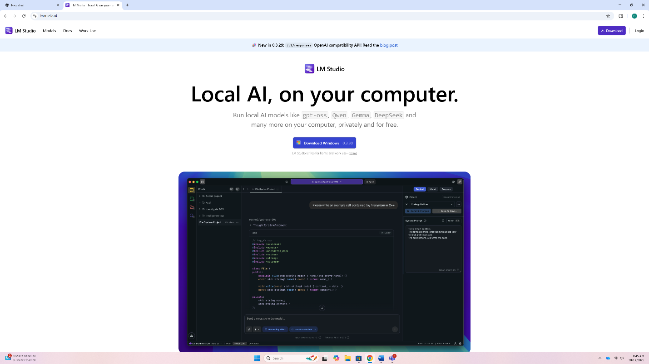
- Opened LM Studio and selected the Gemma 3 12B model, then downloaded it so it could run offline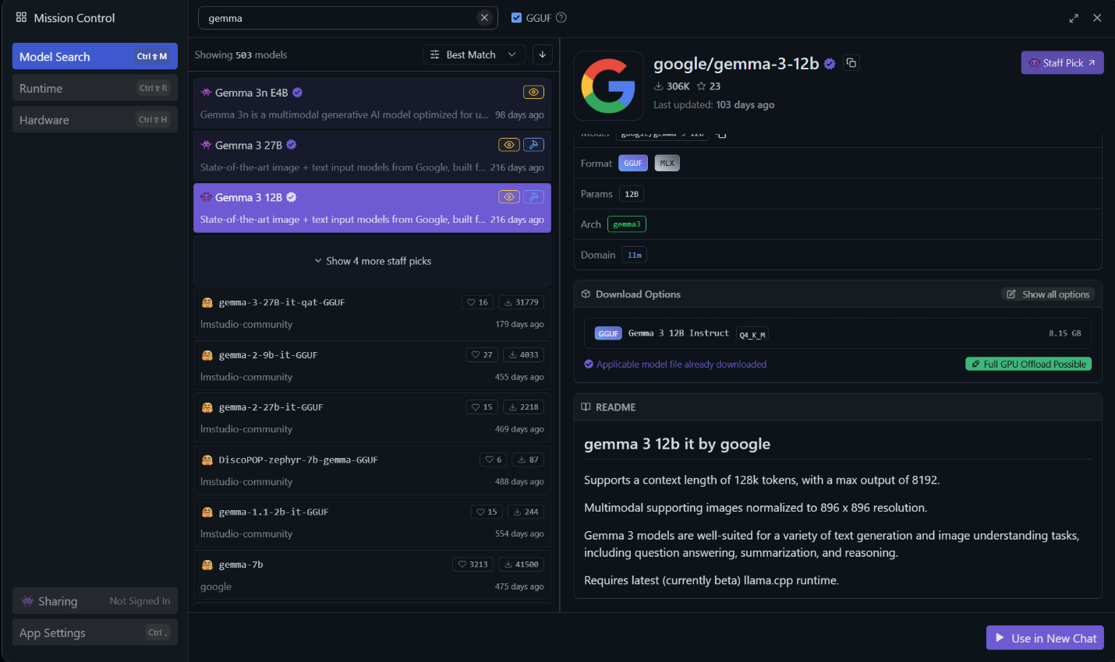

- Started the local server in LM Studio to make sure the AI could be accessed through the local API.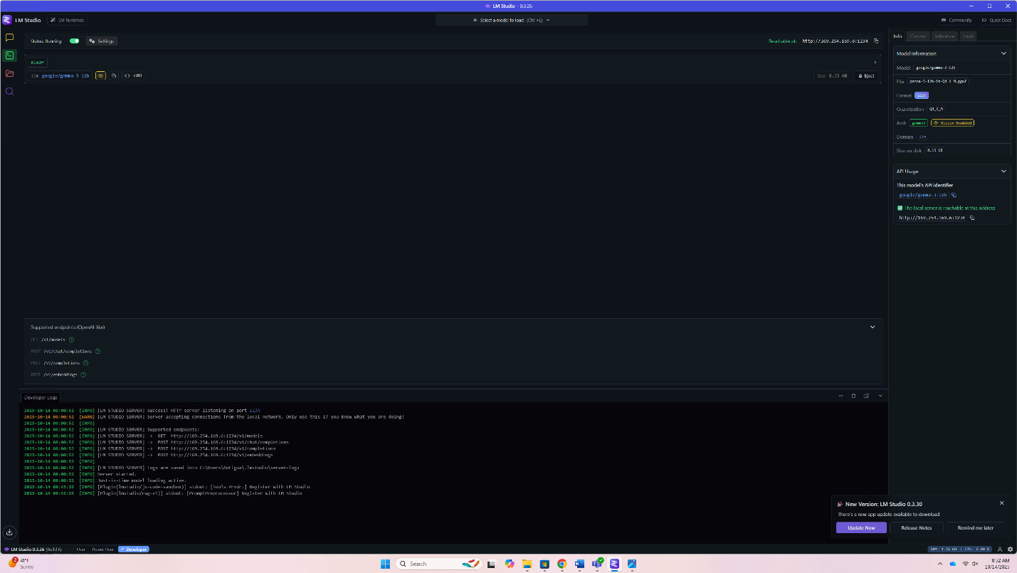

- Downloaded and installed Python from the official website, then verified it was installed correctly using PowerShell.

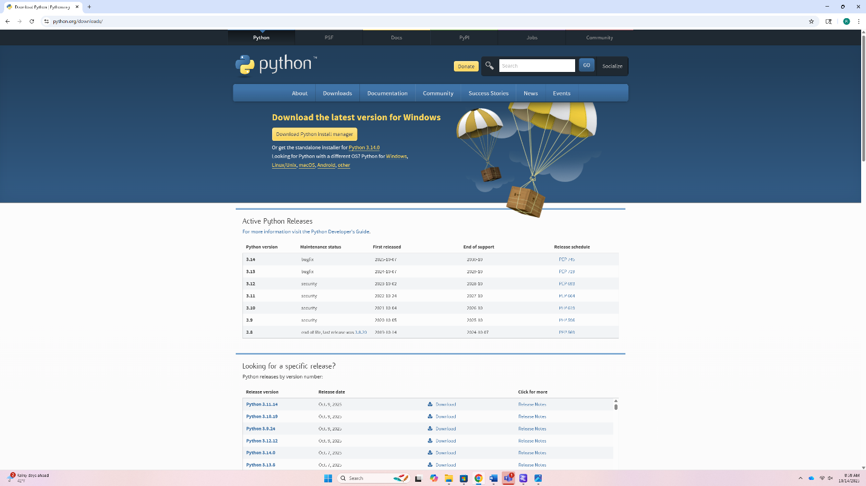
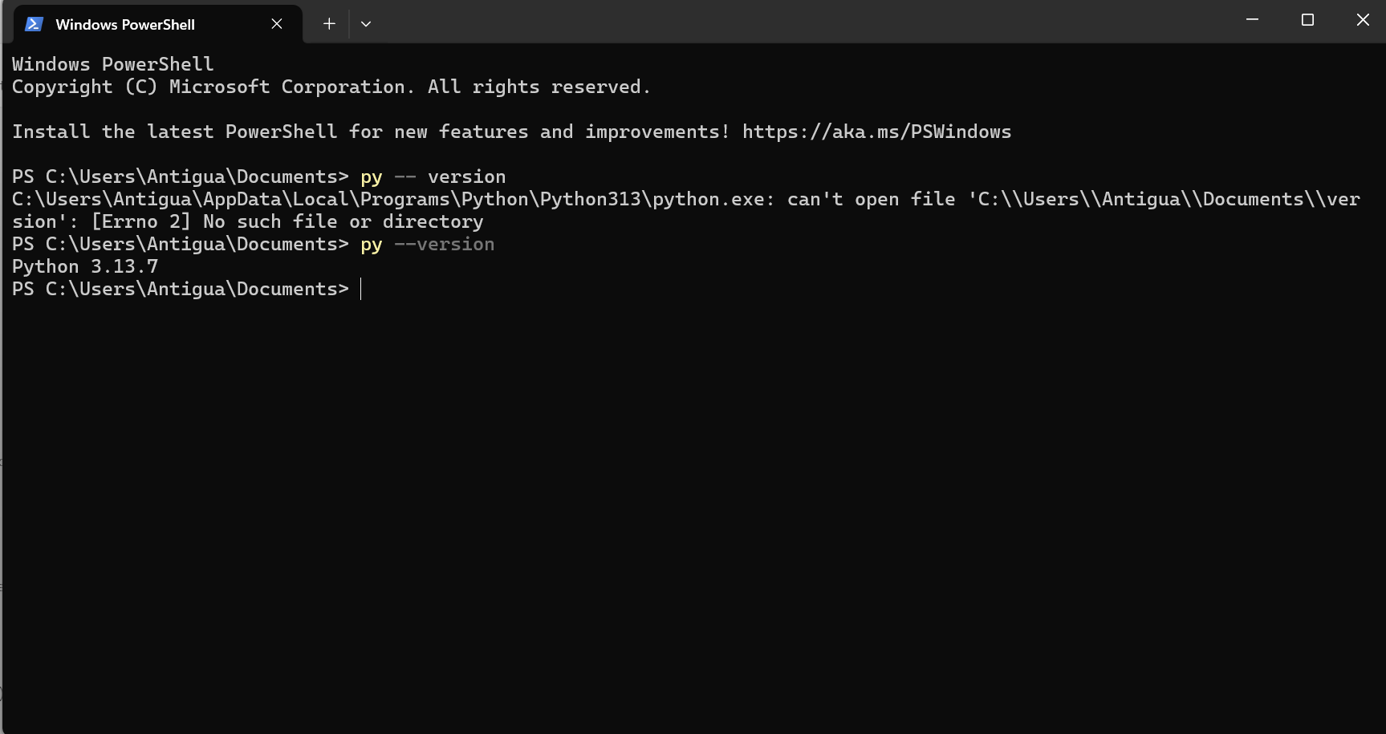
- Installed the required Python libraries, including Gradio and Requests, to build the web interface.
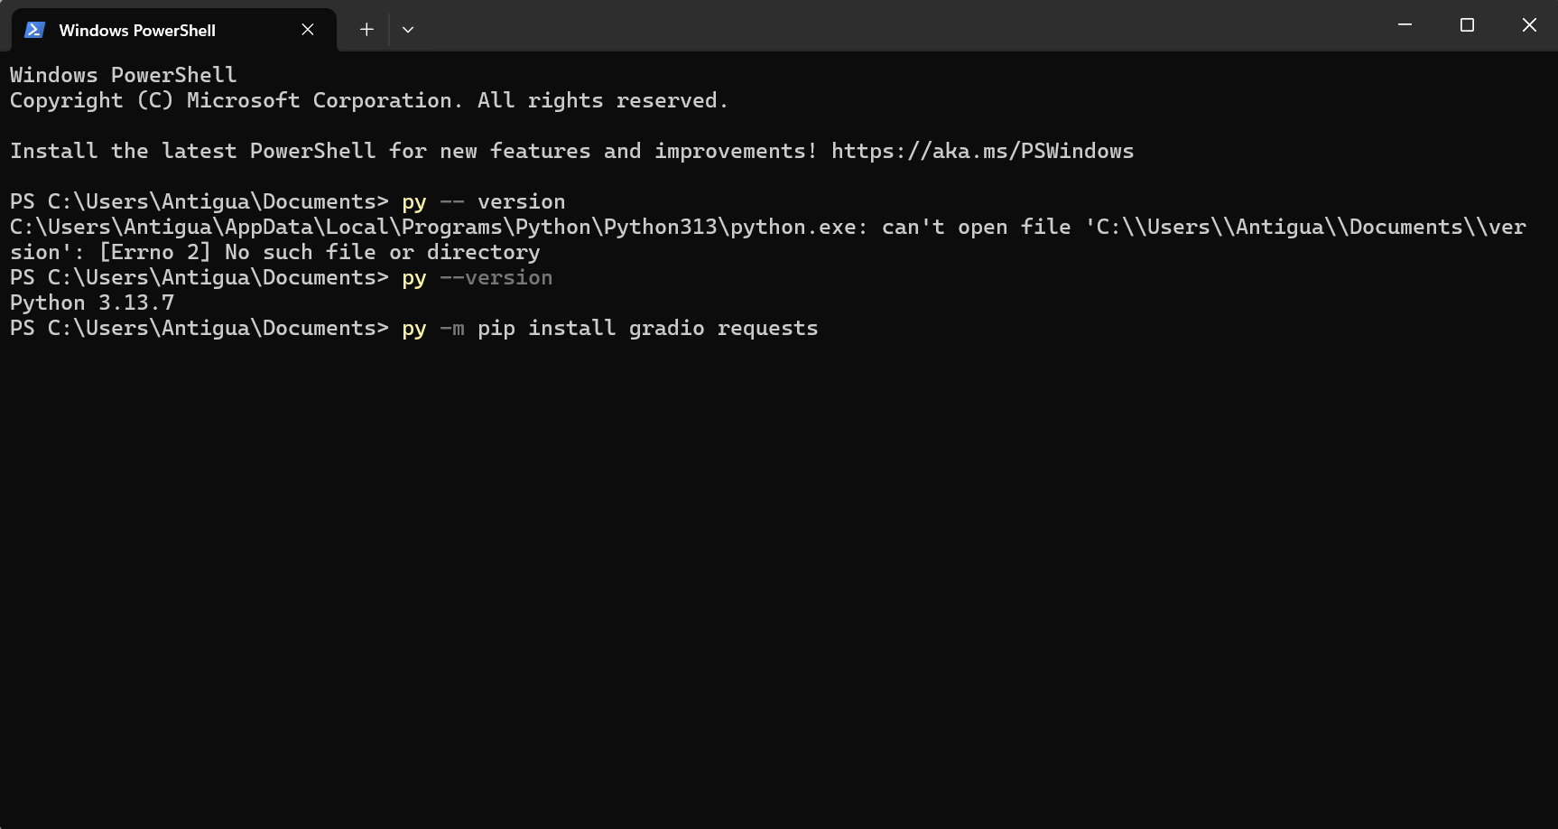

- Created a Python script in VS Code that connected LM Studio’s local API with Gradio. In the script, I imported the Gradio and Requests libraries, set the API link to match the local LM Studio server, and wrote a short function that sent user input to the AI model and returned its response. After that, I added a Gradio interface that created a small chat window where I could type questions and see the AI’s replies.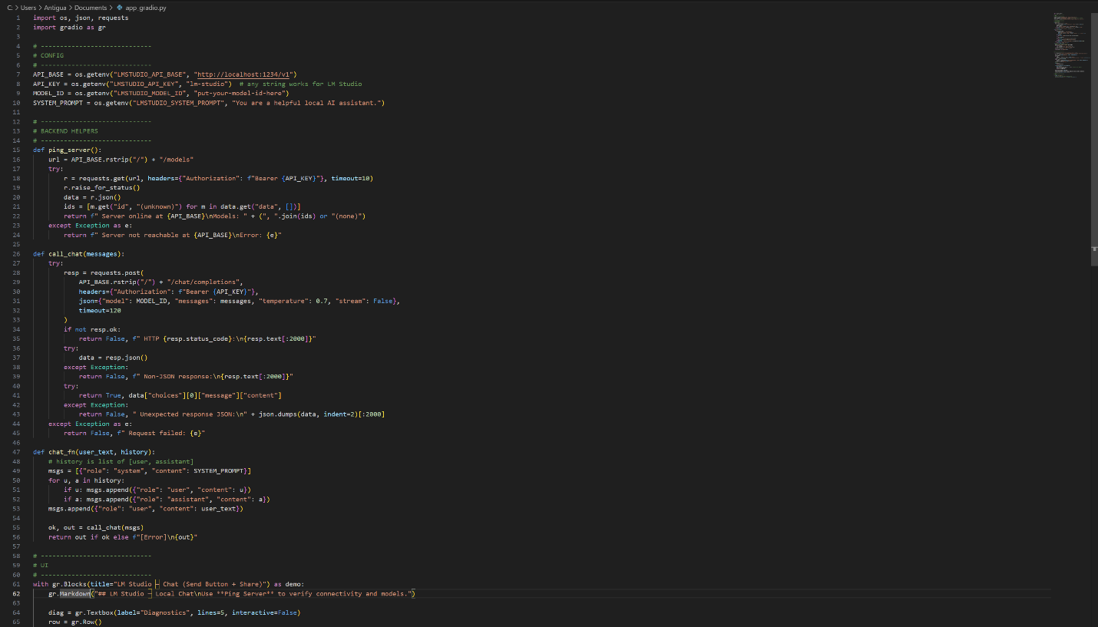
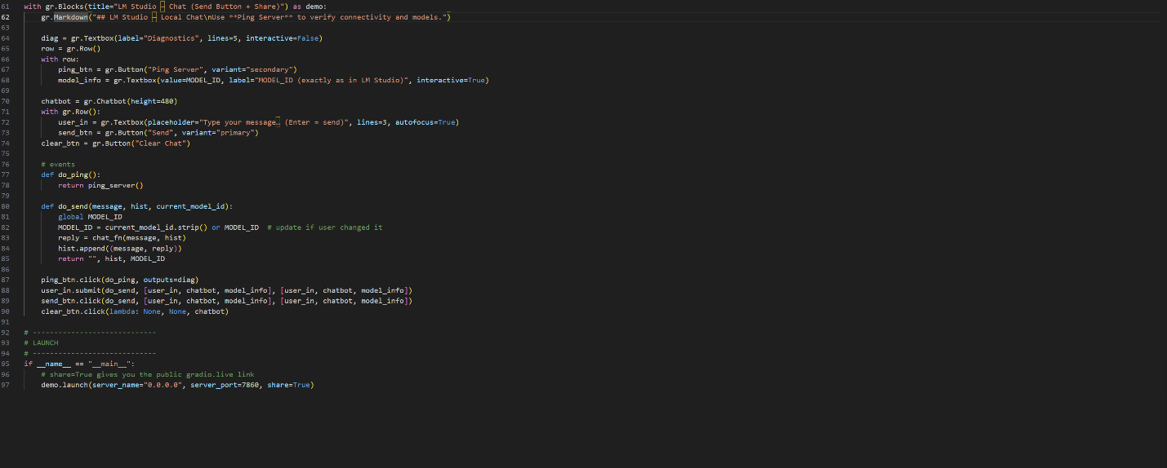

- Ran the Python program and confirmed that the web interface loaded successfully in the browser.
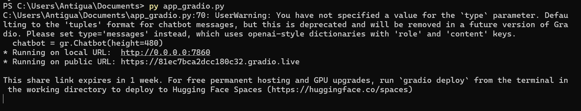

- Tested the local AI chat page by entering prompts and checking that the AI responded correctly through the web server.
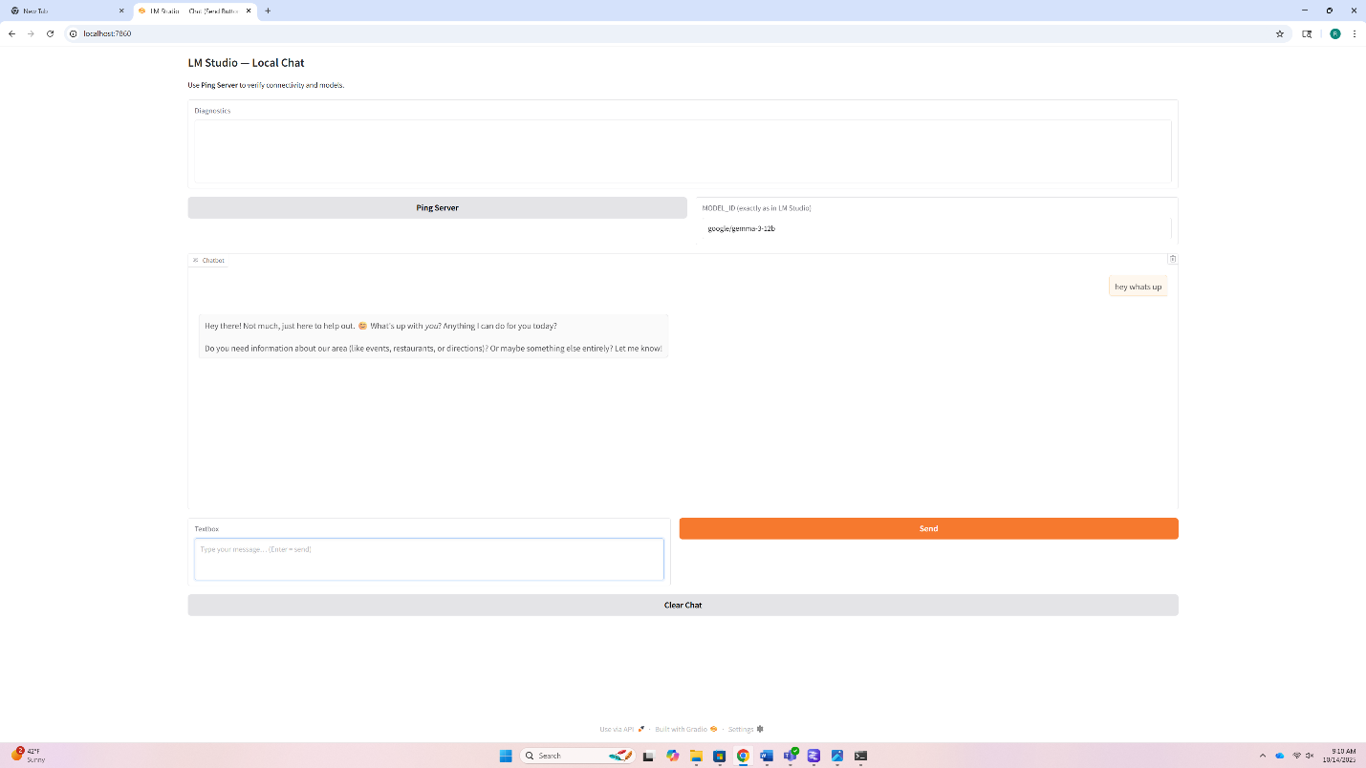

Problems
This lab came with a few problems. The first is when I set up Python and put the code to connect everything together. I ran into a problem during the installation of Python where I downloaded the installer and thought it was installed correctly. But, when I opened PowerShell and typed “python,” it said the syntax wasn’t recognized. I found out that I forgot to enable the option that adds Python to the system PATH. I needed to enable the option so Windows can know where to find the Python. I had to uninstall it, reinstall it, and make sure to check the box to enable Python. After, I tested it again by typing python --version, and it worked.
The next problem came when I started installing Gradio. Every time I tried to run pip install Gradio, it gave me errors saying that “pip” wasn’t a recognized command. I fixed this by updating pip manually with the command python -m ensurepip and running PowerShell as an administrator. After that, Gradio successfully installed. However, when I tried to run my Python, it gave me connection errors to LM Studio. The error said something about “connection refused,” which I realized was because the AI server wasn’t running yet. This is because LM Studio needs to have the AI model downloaded and the API server had to be turned on before the Python could connect. After I started the model and made sure the server was active, Python worked.
Another problem was when I tried to run the Python from PowerShell. There was an error message that my Python wasn’t able to be found even though I could see it in my Documents folder. I realized that PowerShell was looking in the wrong place and was running commands from the main file folder instead of where my Python was saved. To fix it, I used the cd command to change the focus location to my Documents folder where my Python was located. After PowerShell was directed to the correct folder, the Python ran normally.
There was another issue where the Gradio interface was visible but there was no chat box. After I checked my code, I realized I had a syntax typo forgetting quotation marks and indentations in my code that was supposed to generate responses from the AI. Once I fixed the typo and reran the Python, the interface had a chat box.
A smaller issue was with VS Code when opened my code, the installed libraries didn’t get recognized and kept showing red underlines under “import Gradio” and “import requests”. These errors kept happening because VS Code used a different Python interpreter than the one I wanted. I fixed this by going into settings and changing the interpreter path to the correct one.
Overall, most of the problems from this lab came from setup issues and location confusion. Through these problems, I learned through trial and error which helped me understand how the local AI system set up worked.

Conclusion
This lab taught me how local AI systems can be set up and connected through a web server. I learned how to install Python, work with Gradio, and connect a local AI model through LM Studio. Even with the setup issues, those errors helped me understand how different networking and programming systems communicate and work together to set up a local AI system.

